|  |  |  |  |  |
| --- | --- | --- | --- | --- |
| **monday** | tuesday | wednesday | thursday | friday |
|  |  |  |  | 1No School |
| **4** | **5** | 6 | 7 | 8 |
| 11 | **12** | **13** | 14 | 15 1st Grade  Field Trip |
| 18 | **19**  No School | 20 | **21** | **22** |
| 25 No School | 26 | **27**  **Kona Ice 1:30** | 28 Wulfe Bros. 9:30 | 29 Field Day |
|  |  |  |  |  |

#### Classroom Connection

**Word Work Words: zoo, broom, proof, stoop, scoop, noon, root, shoot, spoon, tool.**

**Word Wall Words: Sunday, Monday, Tuesday, Wednesday, Thursday, Friday, Saturday**

**Reading: Genre – Non Fiction**

**Writing: Opinion Piece**

**Math: Fractions**

**Social Studies: Careers**

**Homework:**

**Monday: Write 5 sentences neatly using this week’s words.**

**Tuesday: Math practice sheet**

**Thursday: Study for the Word Work Test.**

**Special Area this Week: Yellow Week**

##### School News

* Please make attendance a priority.

*Please help your child prepare for MAP testing. Reading: Have your child work on Lexia, read with your child and ask them to retell the story.

Compass Math, review math skills such as: tens and ones, time, two digit addition and subtraction. Students are still struggling with knowing when to add or subtract when doing problem solving.

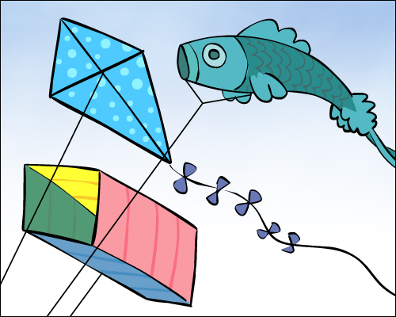

**First Grade “Friendship Company” Newsletter**

## May 4, 2015

May Birthdays!

Rylee Foster – 2nd

Grace Hawkins – 9th

Josh Hernandez - 13th